**Problem 1:** How many nodes are in the West Jordan network? How many zones are in the West Jordan network?

The West Jordan network has **149** nodes and **41** zones.

**Problem 2:** What is the speed limit along 9000 South? How many lanes are present along 9000 South in the Base Condition model?

The speed limit is 39 mph, and the number of lanes is 2.

**Problem 3:** What is link capacity? How is it different from lane capacity?

The link capacity is the capacity of vehicles per hour from a node to a node. It is different than lane capacity as the lane capacity is the capacity of a specific lane while the link capacity is the sum of lanes capacity. Therefore, the link capacity and lane capacity can be equal if the link has only one lane.

**Problem 4:** Describe the link capacity on Redwood Road in the West Jordan Network (how link capacity varies by location, point out bottlenecks, etc.). It might also be a good idea to include the average link capacity and/or use a histogram.

The link capacity on Redwood Road is different by locations. For example, as the link id changes, the link capacity changes accordingly as the link id is the start of a node. The average of the link capacity of Redwood Road was 2164 vph. It was noticed that the link capacity varies as the location and number of lanes vary.

**Problem 5:** What is the number of agents/vehicles to be simulated, as reported in the output_summary.csv file?

The number of vehicles to be simulated is 12,638 vehicles.

**Problem 6:** The first large table in the output_summary.csv file describes summary statistics for each iteration of the simulation. What was the average travel time, average trip time index, average speed, and network clearance time (in minutes) for the last iteration? What pattern do you observe in the average travel times and speeds as the iteration number increases? (Plots might be useful to display these patterns/trends.

30 iterations were performed for the data set. The first iteration results were as follows:

|  |  |
| --- | --- |
| First Iteration | |
| Average travel time (min) | 17.9786 |
| Average trip time index (min) | 3.37114 |
| Average speed (mi./hr.) | 10.0006 |
| The network clearance time (min) | 1440 |

The last iteration (30th) results were as follows:

|  |  |
| --- | --- |
| Last Iteration (30th) | |
| Average travel time (min) | 6.14108 |
| Average trip time index (min) | 1.12151 |
| Average speed (mi./hr.) | 29.1276 |
| The network clearance time (min) | 1440 |

Figure 1: The average time as the iterations increase

Figure 2: The average speed as the iterations increase

It has been noticed that as the iterations increase, the average time decreases until becomes stable by almost the tenth iteration as people would be more familiar day after day.

The average speed has been increased as the iteration increases until the iteration 11 which starts to be stable.

**Problem 7:** Similar to Problem 6, use the first large table in the output_summary.csv file to find the average travel time, average trip time index, average speed, and network clearance time (in minutes) for the last iteration? Do you notice many differences in these values compared to the results for the “no work zone” model?

|  |  |
| --- | --- |
| First Iteration | |
| Average travel time (min) | 28.4359 |
| Average trip time index (min) | 5.33621 |
| Average speed (mi./hr.) | 6.32285 |
| The network clearance time (min) | 1440 |

|  |  |
| --- | --- |
| Last Iteration (30th) | |
| Average travel time (min) | 6.5063 |
| Average trip time index (min) | 1.1643 |
| Average speed (mi./hr.) | 27.9374 |
| The network clearance time (min) | 1440 |

It has been noticed that with work zone model, the average time increases and the average speed decreases comparing with no work zone model.

**Problem 8:** Following the procedure described in Step 5, use screen captures to provide Link MOE plots for Lane Volume and

Speed (in MPH), with 15-minute aggregation intervals, for both links between Node 1 and Node 2 (both directions). This should result in 4 images.

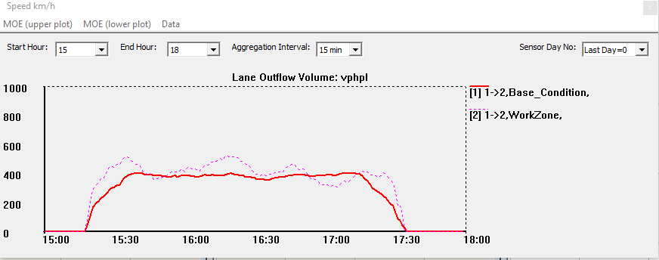

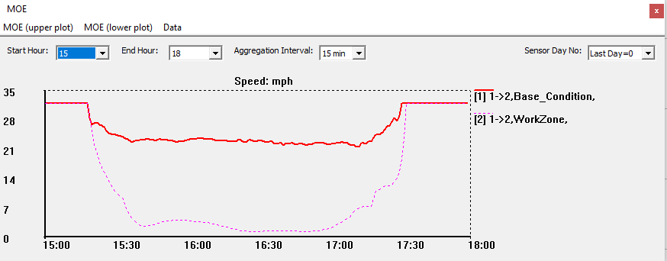

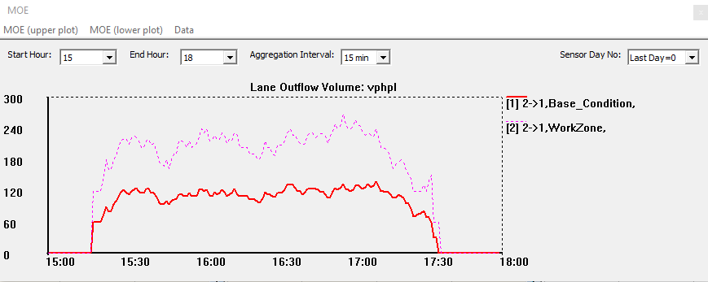

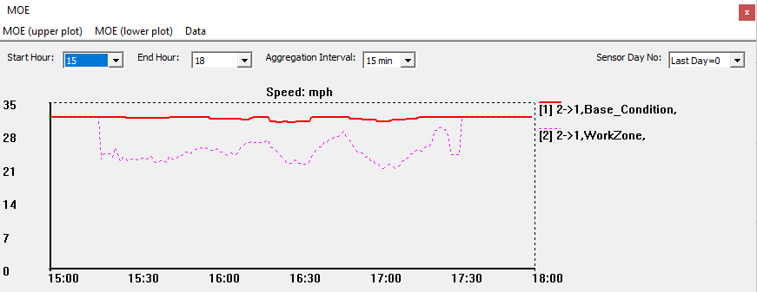

**Problem 9:** From the plots generated in Problem 8, did you notice any differences in speed and volume on these links between the two networks (with and without the work zone)? Do the differences in speed/volume make sense? Does one direction of travel experience more congestion?

Yes, there was a difference in speed and volume on these links between the two networks. From direction 1 to direction 2, it was noticed that the traffic volume was higher in work zone model than the model without work zone. Also, the speed was higher in the model without work zone. Similarly, traffic volume and speed show same pattern in direction 2 to direction 1. These differences make sense as the work zone model shows a less speed and higher traffic volume due to the work zone. Yes, one direction of travel experiences more congestion. Direction 1 to 2 shows more congestion as the traffic volume was almost 500 vph.